Neologix Project – Web Portal

Scope: General Requests

# Introduction

We are working on a web portal in ASP.NET, MVC 5, SQL Server 2014 for our client. The interface is user friendly and easy to navigate through different sections. The end users can come to the web application and request for different services, for example, submitting some forms for getting software licenses, or requesting to review their LAN environment. From our web portal, the developer only need to develop the web pages and update the database. For some cases, need to consume a REST/SOAP based web services.

The project will be developed in phase by phase basis.

We will provide the UI documentation, reference to already created web pages so that you can work on it to create new pages.

Initially the UI will be in English only, but at end of the development Arabic pages also there.

All the content in Arabic for the project should be provided by us

The core architecture is ready for reuse with certain changes, this includes the provision with resource files for implementing Arabic language.

# Expected Development Approach

From below requirement, vendor mostly need to do the add/edit forms based on already completed pages. Then managing Request tab, Subscription tab and Service tab content population. Other tab detail will appear automatically once the vendor insert data in general tables which we will provide guidelines.

For most areas, we have generalized SPs and vendor only need to call this. If there any changes needed, then Neologix team will share guidelines.

There are Export to Excel feature in most of the lists and functionality is already completed. Vendor just need insert data in the table we are specifying. If you are doing any new listing page, then need to follow our approach to achieve the export to excel.

There are areas needed to export form submissions and its excel export feature should be done by vendor by following already implemented approach.

There are Add Comment Popup in detail pages as seen below. Vendor need to follow the already implemented approach and Neologix will provide the guidelines on this.

# Technology

## HTML UI

* 1. HTML5
  2. CSS3
  3. Jquery 1.10.2
  4. jquery.datatables 1.10.12
  5. jQuery.Validation 1.15.1
  6. iCheck 1.0.2
  7. Select2 4.0.3
  8. dropzone 4.2.0

## Development

* 1. Asp.Net 4.5 MVC5
  2. Asp.Net 4.5 WebApi2
  3. Dapper 1.50.2
  4. SimpleInjector 3.2.2
  5. SignalR2 (Not needed for the MaaS developer)
  6. Architecture - similar to Onion Architecture
  7. XML, Ajax, JSON, REST/SOAP API consumption

## Database

* 1. SQL Server 2014

## Other Expertise Needed

* 1. Familiarity with SVN source control

# Features

This project will have the following core functionalities:

## Licensing

The end user requesting for software licenses like windows operating system, Adobe Photoshop or Symantec antivirus. From our web portal, the developer only need to develop the web pages and update the database. For some cases, need to consume a REST/SOAP based web services and in some cases export data submitted through form to excel.

**4.1 Licensing**

4.1.1 Service List

This area showing a list like below.

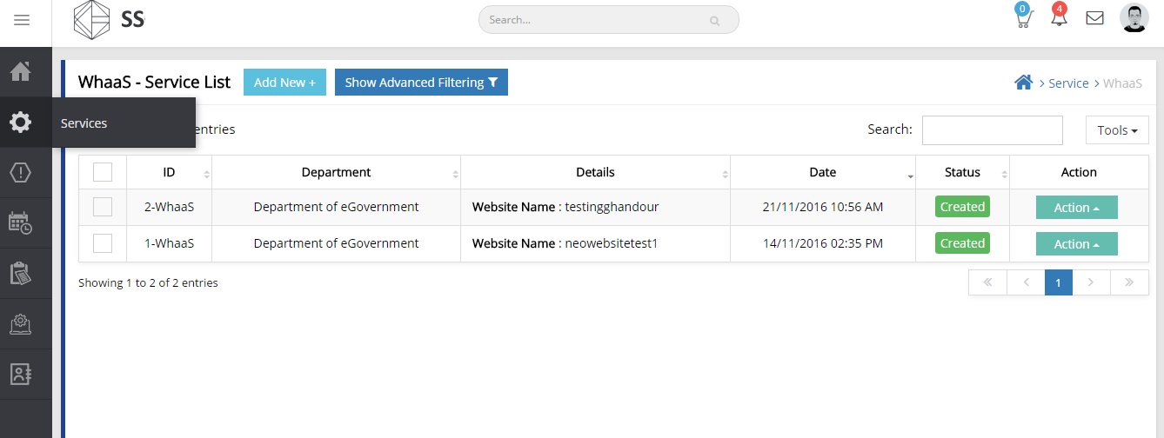

4.1.2 Add New (Microsoft)

4.1.3 Add New (Adobe)

4.1.4 Add New (Symantec Endpoint Security)

4.1.5 Add New (Veritas)

While adding a request, there are different pages depends on type (Microsoft, Adobe, etc.). A sample form may look like below.

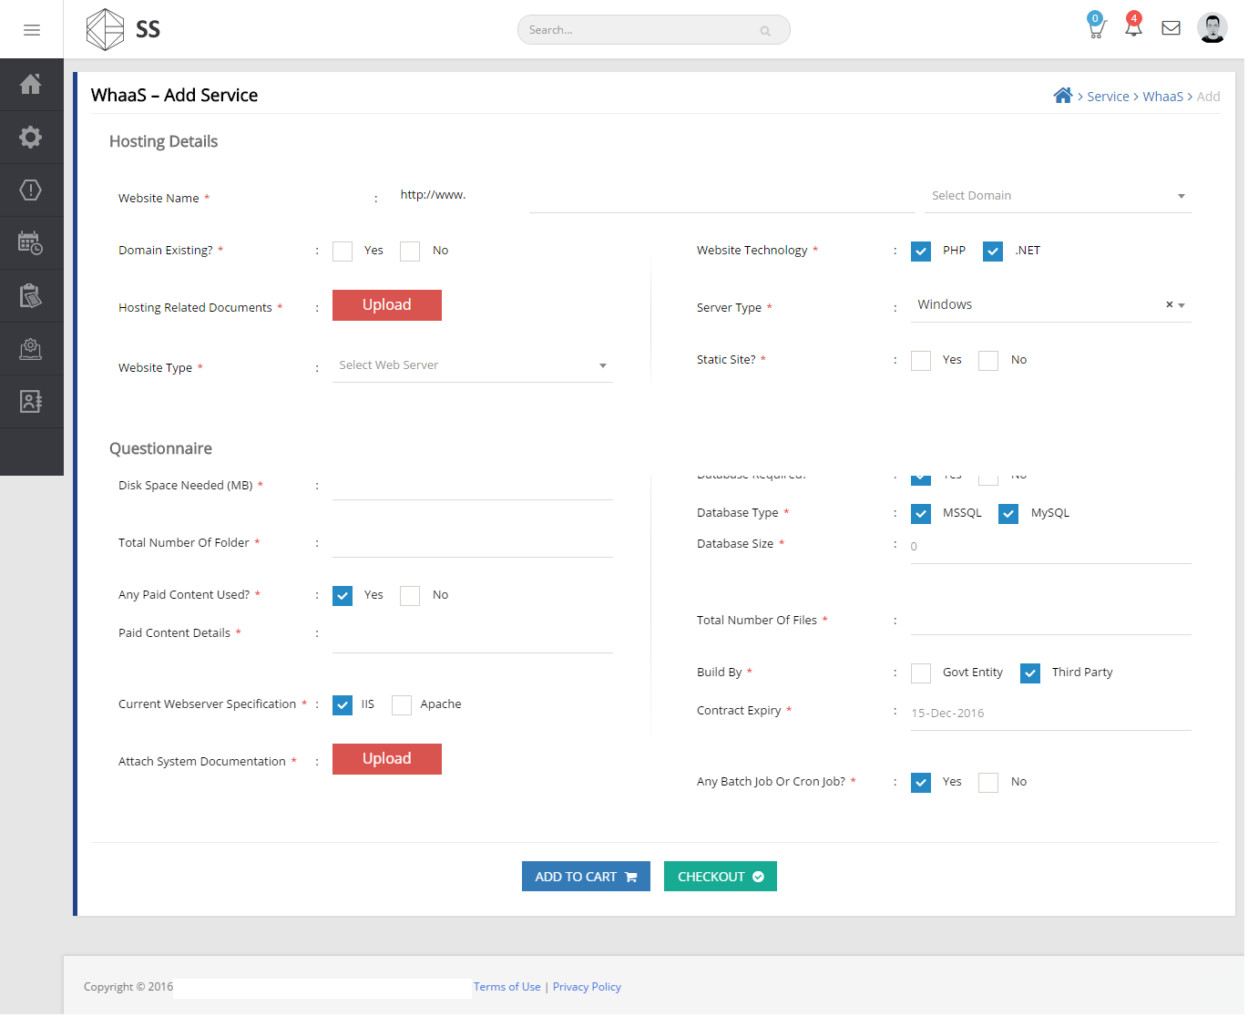

After adding to cart, it will show in a cart page like below:

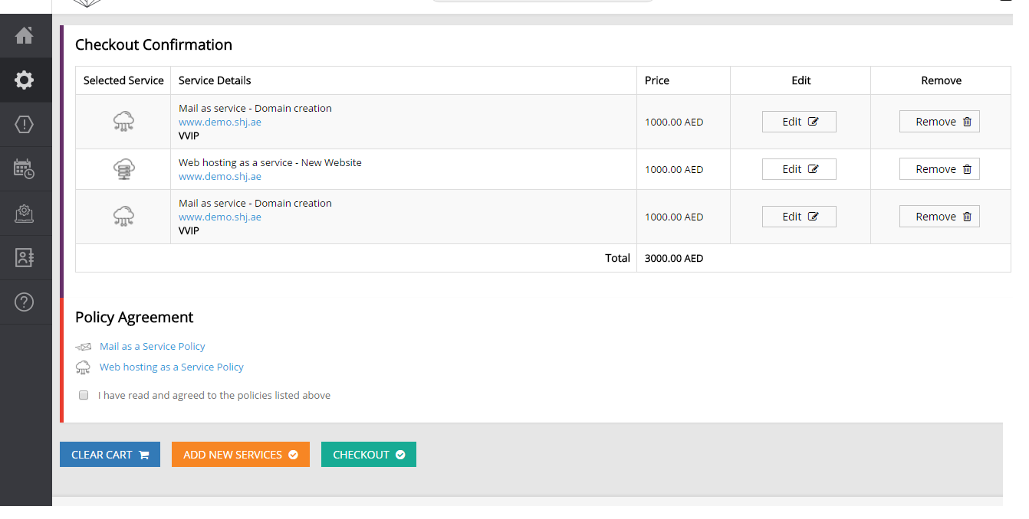

4.1.6 View Details

This detail pages having different tabs as seen below. The actual content for showing here will be provided separately.

4.1.6.1.1 Tab 1 – Request Details

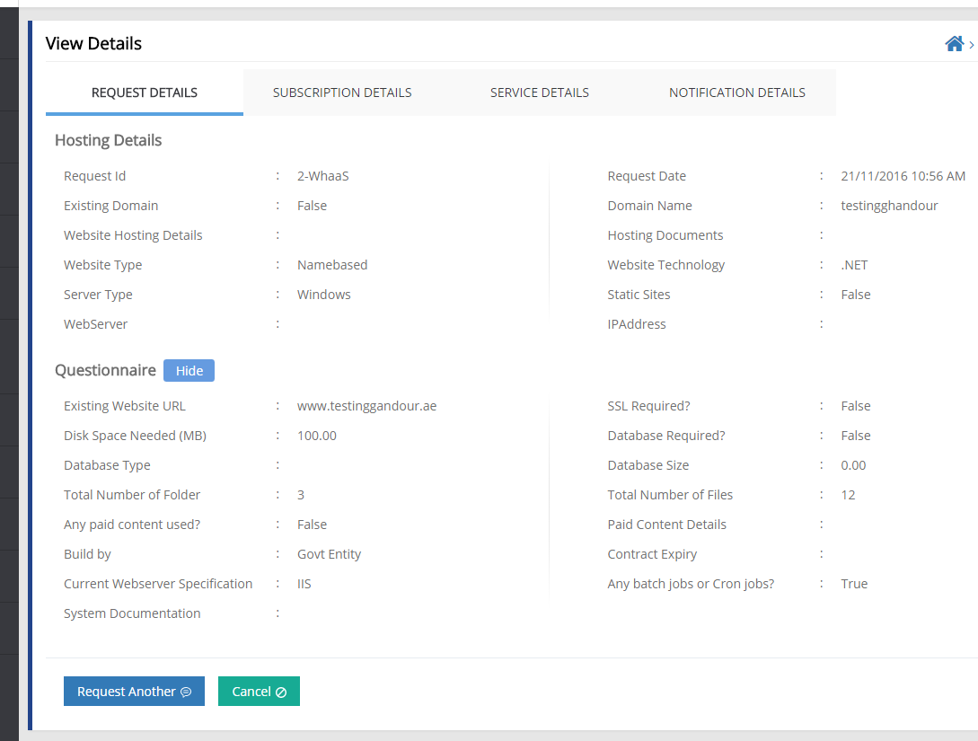

4.1.6.1.2 Tab 2 – Subscription Details

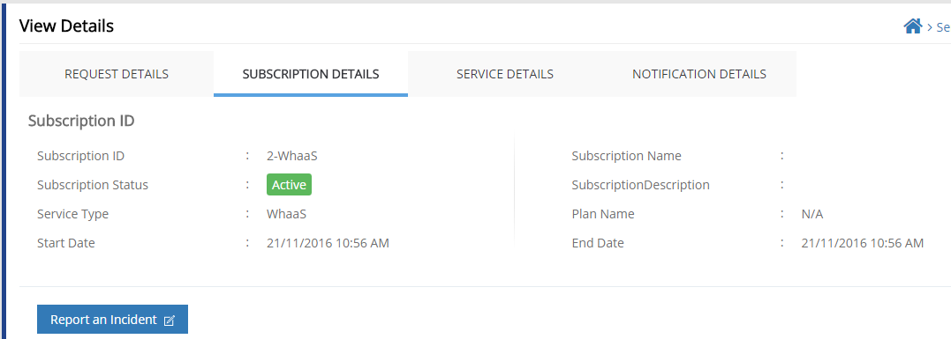

4.1.6.1.3 Tab 3 – Service Details

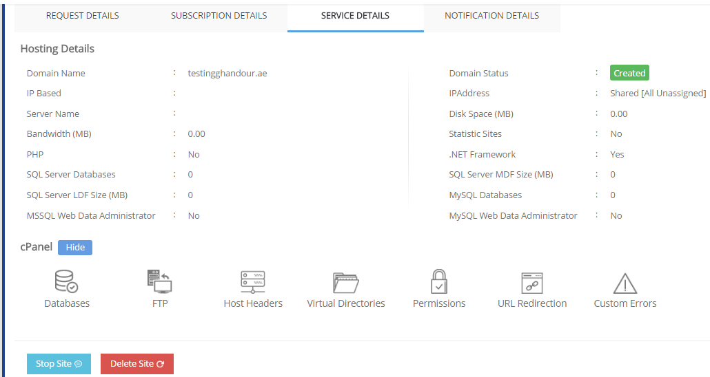

4.1.6.1.4 Tab 4 – History

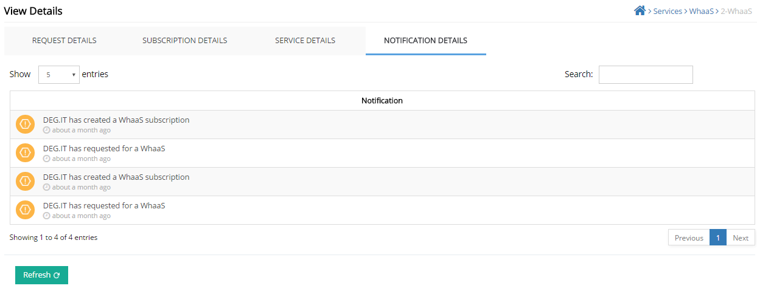

4.1.6.1.5 Tab 6 – Manual Task Checklist

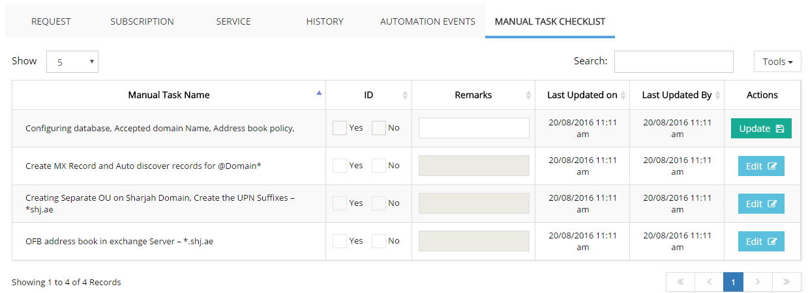

There are other pages just like in above screenshots. Most of the changes are in form submissions. For other pages only difference in data.

**5 Advisory**

**5.1 LAN Optimization**

5.1.1 Service List

5.1.2 Add New

5.1.3 View Details

5.1.3.1.1 Tab 1 – Request Details

5.1.3.1.2 Tab 2 – Subscription Details

5.1.3.1.3 Tab 3 – Service Details

5.1.3.1.4 Tab 4 – History

5.1.3.1.5 Tab 6 – Manual Task Checklist

**5.2 Data Center Assessments**

5.2.1 Service List

5.2.2 Add New

5.2.3 View Details

5.2.3.1.1 Tab 1 – Request Details

5.2.3.1.2 Tab 2 – Subscription Details

5.2.3.1.3 Tab 3 – Service Details

5.2.3.1.4 Tab 4 – History

5.2.3.1.5 Tab 6 – Manual Task Checklist

**5.3 Research**

5.3.1 Service List

5.3.2 Add New

5.3.3 View Details

5.3.3.1.1 Tab 1 – Request Details

5.3.3.1.2 Tab 2 – Subscription Details

5.3.3.1.3 Tab 3 – Service Details

5.3.3.1.4 Tab 4 – History

5.3.3.1.5 Tab 6 – Manual Task Checklist

**5.4 Security Awareness**

5.4.1 Service List

5.4.2 Add New

5.4.3 View Details

5.4.3.1.1 Tab 1 – Request Details

5.4.3.1.2 Tab 2 – Subscription Details

5.4.3.1.3 Tab 3 – Service Details

5.4.3.1.4 Tab 4 – History

5.4.3.1.5 Tab 6 – Manual Task Checklist

**5.5 ISMS Documentation**

5.5.1 Service List

5.5.2 Add New

5.5.3 View Details

5.5.3.1.1 Tab 1 – Request Details

5.5.3.1.2 Tab 2 – Subscription Details

5.5.3.1.3 Tab 3 – Service Details

5.5.3.1.4 Tab 4 – History

5.5.3.1.5 Tab 6 – Manual Task Checklist

**6 Solutions**

**6.1 Booking System**

6.1.1 Service List

6.1.2 Add New

6.1.3 View Details

6.1.3.1.1 Tab 1 – Request Details

6.1.3.1.2 Tab 2 – Subscription Details

6.1.3.1.3 Tab 3 – Service Details

6.1.3.1.4 Tab 4 – History

6.1.3.1.5 Tab 6 – Manual Task Checklist

**6.2 Time Attendance System**

6.2.1 Service List

6.2.2 Add New

6.2.3 View Details

6.2.3.1.1 Tab 1 – Request Details

6.2.3.1.2 Tab 2 – Subscription Details

6.2.3.1.3 Tab 3 – Service Details

6.2.3.1.4 Tab 4 – History

6.2.3.1.5 Tab 6 – Manual Task Checklist

**6.3 Complaints & Suggestions System**

6.3.1 Service List

6.3.2 Add New

6.3.3 View Details

6.3.3.1.1 Tab 1 – Request Details

6.3.3.1.2 Tab 2 – Subscription Details

6.3.3.1.3 Tab 3 – Service Details

6.3.3.1.4 Tab 4 – History

6.3.3.1.5 Tab 6 – Manual Task Checklist

**6.4 Mobile App Development**

6.4.1 Service List

6.4.2 Add New

6.4.3 View Details

6.4.3.1.1 Tab 1 – Request Details

6.4.3.1.2 Tab 2 – Subscription Details

6.4.3.1.3 Tab 3 – Service Details

6.4.3.1.4 Tab 4 – History

6.4.3.1.5 Tab 6 – Manual Task Checklist

**6.5 Correspondence Management System (Zajel)**

6.5.1 Service List

6.5.2 Add New

6.5.3 View Details

6.5.3.1.1 Tab 1 – Request Details

6.5.3.1.2 Tab 2 – Subscription Details

6.5.3.1.3 Tab 3 – Service Details

6.5.3.1.4 Tab 4 – History

6.5.3.1.5 Tab 6 – Manual Task Checklist

**7 Infrastructure**

**7.1 MPLS (Inter Department Connectivity)**

7.1.1 Service List

7.1.2 Add New

7.1.3 View Details

7.1.3.1.1 Tab 1 – Request Details

7.1.3.1.2 Tab 2 – Subscription Details

7.1.3.1.3 Tab 3 – Service Details

7.1.3.1.4 Tab 4 – History

7.1.3.1.5 Tab 6 – Manual Task Checklist

**7.2 Unified Communication**

7.2.1 Service List

7.2.2 Add New

7.2.3 View Details

7.2.3.1.1 Tab 1 – Request Details

7.2.3.1.2 Tab 2 – Subscription Details

7.2.3.1.3 Tab 3 – Service Details

7.2.3.1.4 Tab 4 – History

7.2.3.1.5 Tab 6 – Manual Task Checklist